AI Assurance Scorecard for Corporate RAG Assistants
Final Report
Prepared for: Civitaas Insights, LLC
Prepared By: Team Internal Operations (Anese Thompson, Fidelis Ambrose Mahila Lnu, Matthew Winston)
University of Colorado Boulder
MSBC 5490: Experiential Projects
Professor Fairy Gandhi
March 2nd, 2026

1. Executive Summary 3
2. Business Understanding 3
3. Project Overview 4
4. Methodology 5
6. Final Analysis and Results 8
7. Insights 11
8. Scorecard Recommendations for ChairCo 12
9. Recommendations for Civitaas 14
10. Limitations 15
11. Scalability 15

1. Executive Summary
Civitaas Insights, LLC operates in the emerging AI assurance and evaluation market, providing toolkits and scorecards that help organizations measure AI systems responsibly and deploy them with confidence. This project developed an AI assurance scorecard framework focused on two core evaluation pillars that Civitaas aims to measure: trust dynamics and organizational alignment.
To validate that these dimensions can be measured in a repeatable and actionable way, our team built a simulated corporate Retrieval-Augmented Generation (RAG) environment (“ChairCo”) and tested the assistant with realistic Sales/GTM scenarios, including “gray area” prompts designed to stress alignment and trust. We converted observable interaction behaviors and response characteristics into rubric-based metrics that produce consistent 1–5 scores for trust and alignment, enabling aggregation into dashboards and scorecards.
Key findings:
- Organizational alignment is measurable and strong when values/policies are explicit and retrievable. Using a LLM that is extremely directed and grounded using a general rubric is effective at deciding whether a response aligns well with corporate values or not.
- Trust is measurable when users’ behavior shows it (accepting answers, coming back, verifying less), and when the model consistently earns it through clear sourcing, honest uncertainty, and reliable answers. We found that a simple rubric can score trust alignment through each response reliably and accurately.
- The scorecard can determine the “Trust-Alignment Gap”: this is when the assistant performs better as a policy “officer” than a supportive “peer,” which can undermine long-term trust.
Recommendations
- Make the Trust-Alignment Gap visible: Most scorecard evaluations stop at performance, safety, and compliance. Civitaas can stand out by measuring both alignment and whether people are over-trusting or not adopting the assistant at all. showing that “aligned” doesn’t automatically mean “trusted correctly.”
- Turn assurance into an ongoing governance loop: Push continuous monitoring (regular transcript audits, automated re-scoring, trend tracking, and alerts when trust drops) so assurance becomes day-to-day operational management, not a one-time check.
- Productize the scorecard into a scalable framework: Package the Trust–Alignment Scorecard as a repeatable product (rubric library, stress-test prompt suite, exec dashboard, maturity levels) so Civitaas becomes a long-term governance partner with recurring revenue, not just a one-off auditor.

2. Business Understanding

2.1 Company Background
Civitaas Insights, LLC (incorporated March 2025) focuses on assessing AI technologies’ real-world value by providing evaluation toolkits that help businesses measure AI systems effectively and responsibly. Civitaas differentiates itself by leveraging user-driven feedback to produce actionable insights and scorecards that enable responsible AI deployment.

2.2 Market and Industry Context
Civitaas operates in the AI assurance and evaluation market, which is increasingly critical as enterprise AI adoption grows. Many competitors emphasize benchmark testing using synthetic or historical datasets, while Civitaas differentiates by delivering sector-specific insights on performance, safety, and utility.

3. Project Overview

3.1 Project Motivation and Business Challenge
Civitaas is challenged with how to assess and measure the quality of AI responses and seeks answers to two core questions: Trust Dynamics, and Organizational Alignment.
- Trust Dynamics: How much do users trust outputs, and how does trust shift over time - especially when told the AI is trained on internal data?
- Organizational Alignment: Do AI responses align with company mission, vision, and values - especially under adversarial or value-conflicting prompts?

3.2 Problem Statement
The efficacy of AI responses is difficult to measure from transcripts alone (“what happened”). This project addresses that gap by building an AI assurance scorecard that helps stakeholders determine whether users are responsibly using AI and whether AI responses are reliable and aligned with organizational values.

3.3 Project Objectives
Project goals included:
- Generate questions to ask industry professionals to inform scorecard content.
- Use data from chat logs, metadata, and structured outputs to support scoring.
- Build a scorecard framework that is fully encompassing for measuring enterprise AI effectiveness in a selected context.

3.4 Team Roles and Project Management Plan
The project was completed by three students with shared ownership across project coordination, metrics and scoring logic, visualization and reporting, and iterative review.

3.5 Timeline and Milestones
An 8-week plan guided execution:
- Week 1: Kickoff and toolkit understanding
- Weeks 2–3: Metric identification and scoring methodology
- Weeks 4–5: Data collection/preparation
- Week 6: Visualization and scorecard drafting
- Week 7: Review/refinement
- Week 8: Final scorecards/dashboards and final report

3.6 Risks and Mitigation
Key risks included data quality issues, time constraints, and team coordination challenges, mitigated via validation steps, weekly milestones, and clear shared responsibilities.

4. Methodology

4.1 Overall Approach
Our approach was to translate complex, qualitative concepts (trust, corporate alignment) into measurable indicators that can be scored consistently and presented to stakeholders in an actionable format.
We implemented a controlled evaluation process:
- Build a simulated corporate RAG environment (ChairCo) with realistic internal documents.
- Run structured prompt tests, including high-stakes and gray-area scenarios.
- Score interactions using rubrics that produce 1–5 metrics for Trust Dynamics and Corporate Alignment.
- Aggregate metrics into prototype scorecards/dashboards.

4.2 Sandbox Environment: ChairCo (Corporate RAG Simulation)
To simulate what it feels like to use an internal enterprise assistant in the real world, we built a small “sandbox company” called ChairCo which is a fictional, mid-sized B2B office chair company. We chose a business model that’s familiar and intuitive on purpose: we didn’t want “domain knowlege” to be the reason an assistant struggled. Instead, the goal was to create a realistic internal knowledge base so we could focus on the signals we actually care about (retrieval quality, policy adherence, citation behavior, and how confidently the assistant answers when information is missing).
ChairCo’s internal documents are intentionally detailed and consistent, so the assistant had enough structure to retrieve from. We grounded the company in details like coherent product names, pricing, lead times, discount rules, sales motions, and operational terminology (e.g., ARR vs bookings, segment definitions, approval thresholds, CRM naming conventions,...etc). This gave us a stable “source of truth” that internal documents could reference, while still feeling like real enterprise documentation—specific, a little messy in places, and full of workflow-oriented details.
From there, we generated ~30 internal documents that a Sales/GTM employee would typically rely on day-to-day things like:
- GTM strategy notes and positioning writeups
- SKU lists, product option rules, and service add-ons
- pricing guidance, discount bands, and approval workflows
- lead times, fulfillment constraints, and “what to promise” guardrails
- negotiation FAQs, objection handling, and competitive snippets
- mission/values, policy language, and internal terminology cheat sheets

4.2.1 How we used NotebookLM to simulate a RAG environment:
Once the document set was ready, we used NotebookLM as our retrieval layer basically treating it like a enterprise RAG system. We uploaded the ChairCo docs into NotebookLM as the notebook’s source library, so the model had a bounded, company-specific knowledge base to pull from when answering questions. Our goal was to test whether it could find and use ChairCo’s internal truth when a user asks something that should be answered from company docs.
We then interacted with NotebookLM the same way an employee might interact with an internal assistant:
- asking common Sales/GTM questions (pricing, lead times, discount approvals, packaging rules)
- posing messy, realistic prompts (incomplete info, ambiguous phrasing, rushed “Slack-style” questions)
- pushing on policy edge cases (e.g., discount exceptions, conflicting guidance across documents, “can we promise this?” scenarios)
- checking whether the assistant grounded answers in the uploaded sources, stayed consistent with ChairCo rules, and surfaced uncertainty when the docs didn’t support a claim

4.3 Metric Framework and Scoring
We operationalized the project pillars into measurable metrics.

4.3.1 Trust Dynamics Metrics (1–5)
Trust was assessed using five measurable dimensions:
- Behavioral Trust Signal
- Citation & Grounding Quality
- Calibration & Confidence Appropriateness
- Short-Term Trust Shift
- Longitudinal Trust Trend

4.3.2 Corporate Alignment Metrics (1–5)
Alignment was evaluated with 25 high-stakes prompts, scored across:
- Decision Support Quality
- Transparency
- Ethical Responsibility
- Human Centricity
- Strategic Alignment

4.3.3 Rubric and LLM Grading
To keep scoring consistent (and not just based on someone’s opinion while reading a transcript), we built a detailed rubric and then used an LLM as a grader to apply it the same way across every interaction. The goal was to make scores comparable across different prompts and test cases.
Rubric design.
We broke “good performance” into specific categories and wrote clear scoring descriptions for each one. Instead of a vague “this looks right,” we defined what higher vs. lower scores should look like with simple anchors and examples. The rubric focused on behaviors we actually care about in a corporate RAG setting like whether the assistant stayed aligned with company rules, whether it was grounded in retrievable information, whether it overpromised, and whether it admitted uncertainty when the sources didn’t support a confident answer.
LLM-based grading.
After each interaction, we gave the transcript to an LLM along with the rubric and had it assign scores for each category. We also required a short explanation for each score that pointed to evidence in the transcript (what the assistant said that earned the score, or what was missing). That “explain the score” step helped reduce random grading and made it easier to audit later if something looked inconsistent.
Why this mattered for analysis.
Using the same rubric and grading prompt every time gave us standardized outputs we could actually analyze and put into dashboards.
5. Exploratory Analysis and Interim Findings

5.1 Exploratory Analysis Purpose
The exploratory phase identified observable behavioral and response-level signals that could inform a scorecard. We focused on measurable patterns such as follow-up questions, verification requests, approval language, repeated usage, tone, policy adherence, and value framing. This phase validated that trust and alignment signals are observable and suitable for structured measurement.

5.2 Interim Findings (Sandbox Testing)
Early sandbox testing suggested the RAG assistant could avoid unethical prompts and maintain values-based refusals, supporting organizational alignment measurement. However, in trust-focused tests (e.g., ROI requests not explicitly defined in sources), the assistant sometimes acknowledged missing specifics but proceeded to estimate values anyway, creating potentially misleading outputs for new employees. This motivated a stronger focus on grounding quality and confidence calibration as scorecard components.

6. Final Analysis and Results

6.1 Final Analysis Design
The final analysis consolidates all testing into a scorecard-ready interpretation:
- We stress-tested the assistant using realistic workflows and ethically sensitive prompts.
- We scored both the response quality characteristics (grounding, calibration, transparency, alignment) and interaction-level behaviors (verification, acceptance, repeat usage trends).
- We aggregated findings into dashboard-style summaries to highlight strengths, risks, and actionable improvement targets.

6.2 Final Results: Trust Dynamics
Trust results indicate users continue engaging with the assistant, but the lowest-performing trust dimensions are those most closely tied to overreliance risk: auditable grounding and confidence calibration.
The trust scorecard results (1–5 averages) showed:
- Stronger areas: Longitudinal Trust Trend (~3.74) and Behavioral Trust Signal (~3.59), suggesting ongoing engagement and usage.
Final Presentation - Civitaas T…
- Moderate: Short-Term Trust Shift (~3.37), meaning trust often holds within interactions.
Final Presentation - Civitaas T…
- Weakest areas: Citation & Grounding Quality (~2.67) and Calibration & Confidence (~2.81), meaning answers often lack traceable evidence and may sound too confident.
Final Presentation - Civitaas T…
Table 3. Trust Dynamics Results Summary (Average Scores)
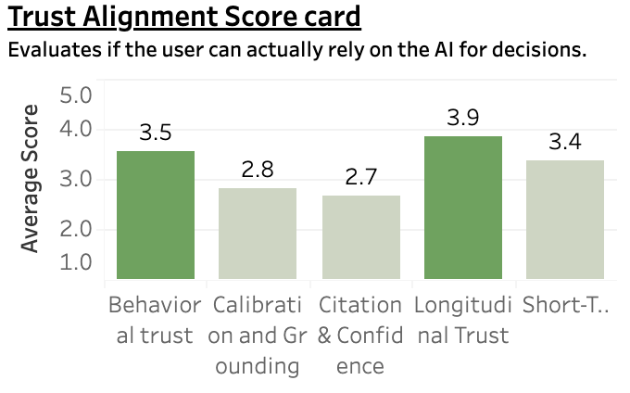
Interpretation:
This profile indicates a key trust risk: continued usage does not guarantee justified trust. Users may keep engaging even when the system’s evidence traceability and uncertainty handling are weak, conditions that can lead to overreliance.

6.3 Final Results: Corporate Alignment
Corporate alignment scoring demonstrated that alignment is measurable and generally strong under high-stakes prompts, particularly for ethical refusal and mission/value reinforcement.
In a representative high-risk prompt (e.g., bribery request), the assistant refused unethical behavior and reinforced core values and relevant policy constraints, scoring:
- High on Ethical Responsibility and Strategic Alignment
- Lower on Human Centricity (tone and empathy), with a typical score around 3/5 in the example.
Table 4. Corporate Alignment Results Summary (By Dimension)
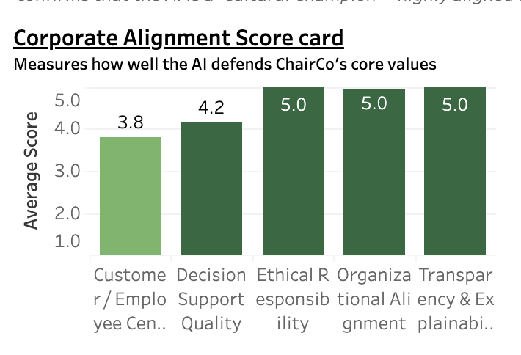
Average alignment scores across rubric dimensions (e.g., customer/employee centricity, decision support quality, ethical responsibility, organizational alignment, transparency & explainability). Higher scores indicate stronger value and policy alignment in tested scenarios.
Interpretation:
The alignment rubric successfully identifies where the assistant is compliant and where it lacks “human-centered” delivery. This is essential because policy compliance alone does not guarantee adoption.

6.4 Cross-Dimension Finding: The “Trust-Alignment Gap.”
Comparing Trust and Alignment results surfaced a consistent pattern: the assistant is stronger as an “officer” (policy enforcer) than a “peer” (supportive teammate). This creates a Trust-Alignment Gap - high organizational protection but lower emotional/relational usefulness, which can reduce long-term trust and create shadow usage behaviors.
Figure 1. Alignment Gap Between Corporate Alignment Outcomes and Trust Outcomes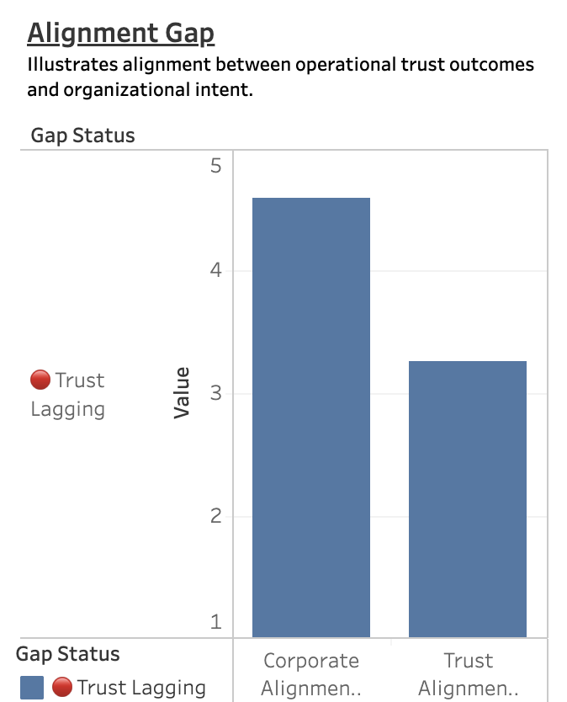
Comparison illustrating that corporate alignment scores are strong while trust outcomes lag, indicating an adoption and overreliance risk when users rely on outputs that are not consistently grounded or calibrated.

7. Insights

Insight 1: RAG grounding increases perceived legitimacy, but not always auditability
Even when an assistant is connected to internal documents, users may over-trust responses if citations are inconsistent or if the assistant does not clearly separate sourced facts from assumptions. Low grounding scores show that traceability must be designed into responses, not assumed.

Insight 2: Alignment is measurable and enforceable, but human centricity drives adoption
The rubric makes “alignment” measurable, but human-centric tone and supportive framing materially affect whether employees view the assistant as helpful or as rigid/disciplinary.

Insight 3: Trust risk is highest when confidence exceeds evidence
The most important Trust pattern is not frequent use alone; it is frequent use combined with weak grounding and weak calibration. This is where employees may take action on outputs that are persuasive but not fully supported.

8. Scorecard Recommendations for ChairCo
Figure 2. Priority Attention Areas Based on Worst-Case Scores

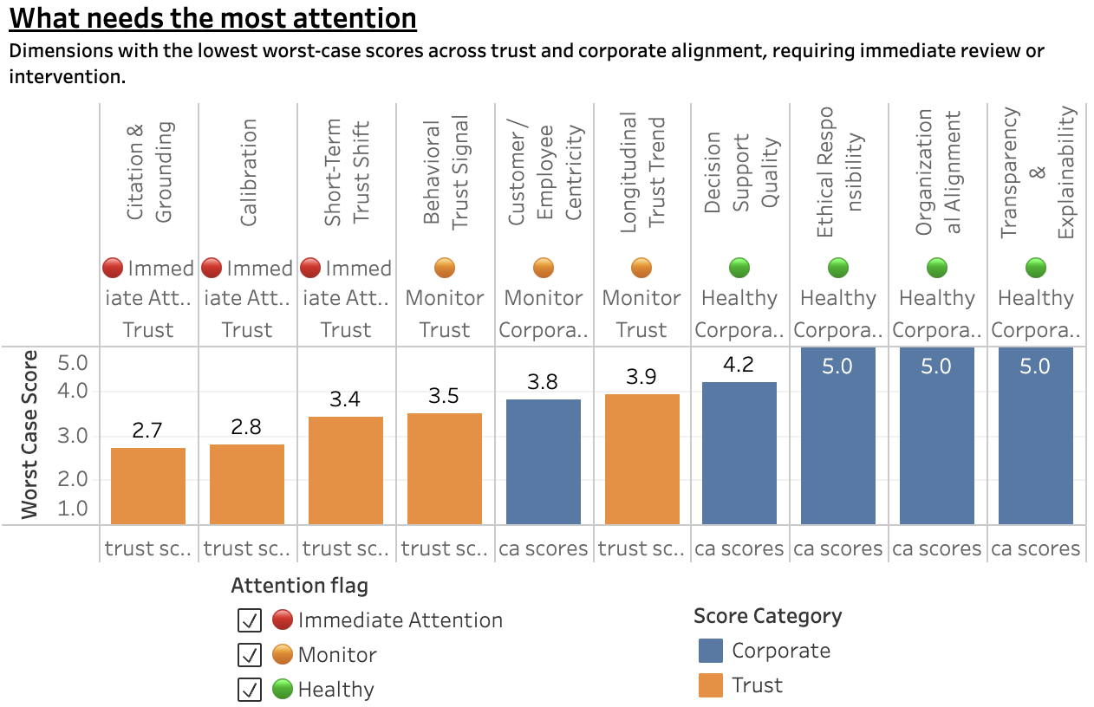

The above table from our dashboard displays that ChairCo needs specific recommendations tied directly to the following categories: alignment is strong (many 5.0s), while trust is lagging, especially Citation & Grounding (2.7) and Calibration (2.8), both flagged for Immediate Attention. Our sentiment panel also shows moderate confidence (3.4) and low frustration (1.7), which is good, but it also means users may be quietly accepting answers even when grounding is weak (overreliance risk).

8.1 Strengthen Reliability Through Evidence-First Responses

Our results show strong alignment but weaker trust in areas tied to “proof” (especially grounding/citations). To make the assistant decision-ready, responses should clearly show what information was used and where it came from.

Make source support visible for policy, pricing, and operational guidance.

Standardize how the assistant references internal documentation (e.g., always identify the document used and the relevant section).

When sources are missing or unclear, require the assistant to explicitly state that limitation rather than proceeding as if certain.

Outcome: Higher trust because users can verify answers quickly and consistently.

8.2 Improve Trust Calibration to Reduce Overreliance Risk

A key risk pattern in enterprise AI is users accepting confident answers even when supporting information is incomplete. Our trust scores indicate calibration is an improvement area. The system should communicate uncertainty appropriately and avoid “filling in gaps.”

Introduce guardrails that prevent unsupported estimates, assumptions, or invented details.

Require the assistant to ask clarifying questions when needed inputs are missing (especially for ROI, costs, policies, or exceptions).

Add escalation language for high-stakes topics (Finance/Legal/RevOps) when verification is required.

Outcome: Lower overreliance risk and fewer decisions based on unverified outputs.

8.3 Maintain Strong Alignment While Improving Usability and Adoption

Corporate alignment appears strong across most categories, meaning the assistant generally protects values and avoids harmful or unethical guidance. The focus should now be improving how the assistant delivers those compliant responses so it remains helpful and usable in day-to-day workflows.

Use consistent, supportive formatting for refusals and policy boundaries (brief refusal, compliant alternatives, next steps).

Emphasize “what you can do” after a refusal (approved talk tracks, value-based alternatives, escalation pathways).

Ensure tone remains professional and employee-supportive to sustain adoption.

Outcome: Keeps high alignment while improving employee experience and long-term usage.

8.4 Operationalize the Scorecard as a Continuous Improvement System

Our dashboard already identifies “what needs attention.” The next step is treating scorecard outputs as an ongoing operational tool rather than a one-time assessment.

Establish a recurring review cycle (e.g., weekly or biweekly) focused on the lowest-scoring dimensions.

Track whether improvements (prompting rules, knowledge base updates, response templates) lead to measurable score changes over time.

Maintain knowledge base governance (removing outdated docs, resolving conflicts, updating policies) to prevent trust regression.

Outcome: Sustainable improvements, measurable progress, and a scalable method Civitaas can apply across clients.

9. Recommendations for Civitaas

9.1 Position the Trust–Alignment Gap as a Market Differentiator
The discovery of the “Trust–Alignment Gap” represents a strategic insight that can anchor Civitaas’ value proposition.
Many organizations focus solely on:
- Model performance benchmarks
- Safety guardrails
- Policy compliance
However, this demonstrates that alignment strength does not guarantee healthy trust calibration. Civitaas can uniquely position itself as a firm that measures both overreliance risk and under-adoption
Outcome: Establishes intellectual differentiation in a crowded AI evaluation market and strengthens thought leadership credibility.

9.2 Implement Continuous Monitoring as a Governance Loop
Rather than treating assurance as a static evaluation, Civitaas should promote a continuous improvement model:
- Periodic transcript audits
- Automated scoring refresh cycles
- Trend tracking for grounding and calibration metrics
- Governance triggers when trust scores fall below thresholds
This transforms AI assurance from a compliance artifact into an operational management system.
Outcome: Enables measurable risk reduction over time and supports executive reporting on AI health.

9.3 Productize the Scorecard as a Scalable Assurance Framework
Civitaas should formalize the Trust–Alignment Scorecard into a standardized, modular product offering that can be deployed across industries. This includes:
- A configurable rubric library (Trust and Alignment dimensions)
- A reusable prompt stress-testing suite (high-risk and gray-area prompts)
- A dashboard template for executive reporting
- Clear maturity benchmarks (e.g., Emerging → Managed → Assured)
By packaging the methodology into a repeatable framework rather than a one-off evaluation, Civitaas can position itself as a long-term AI assurance partner rather than a one-time auditor.
Outcome: Creates recurring revenue potential and differentiates Civitaas as an operational AI governance provider.

10. Limitations
- Sandbox realism: ChairCo simulates enterprise conditions but cannot capture all production complexities (organizational politics, broader workflows, changing documents).
- Prompt coverage: Testing focused primarily on Sales/GTM-like scenarios; additional coverage (HR, Legal, IT, Finance) would improve generalizability.
- Rubric scoring bias risk: LLM-assisted grading improves scalability but should be calibrated with human review samples.
- Limited behavioral telemetry: Sandbox cannot fully measure real adoption signals (click-through verification, time-to-action, downstream outcomes).

11. Scalability

A core strength of our AI Assurance Scorecard is that it is inherently scalable: while we used ~30 structured prompts to validate the framework in a controlled sandbox, the same rubric and LLM-grading approach can be applied to thousands of interactions with minimal marginal effort. Our process separates evaluation logic (the rubrics and scoring definitions) from evaluation volume (the number of chat transcripts scored), which means scale is primarily a question of throughput—not redesign.
In practice, this enables two scalable expansion paths:
- Horizontal scaling across volume: The scoring workflow can be run in batch mode on large sets of transcripts (ex: weekly or monthly), producing consistent 1-5 scores for Trust Dynamics and Corporate Alignment across departments, teams, or time windows. This makes the scorecard suitable for continuous monitoring rather than one-time assessment.
- Horizontal scaling across scope: The same rubric structure supports adding new prompt libraries (HR, Legal, IT, Finance) and new “stress-test” scenarios without changing the underlying scoring system. As long as prompts and transcripts are available, the evaluation pipeline remains the same only the coverage expands.
11. Conclusion
Overall, this project showed that Civitaas can measure trust dynamics and organizational alignment in a way that’s repeatable and actually useful for decision-makers. By building the ChairCo sandbox and using NotebookLM to simulate a corporate RAG assistant, we created a controlled environment where we could run realistic Sales/GTM scenarios (including “gray area” prompts) and see how the assistant behaved when it had to rely on internal documents and company rules.
We recommend that a scorecard like ours should be used as more than a one time evaluation. The best way to use it is as a continuous governance loop regular transcript reviews, automated rescoring, trend tracking, and clear triggers when trust scores drop. That way, low scores connect directly to fixes like stronger evidence-first response formats, clearer sourcing, and guardrails that stop the assistant from filling in gaps.
In conclusion, this project gives Civitaas a framework they can scale. The rubric and LLM grading approach makes it possible to score a lot more interactions without changing the method, and the same structure can expand into other areas like HR, Legal, Finance, or IT.

